Here is the information on assigning hot keys to the buttons in Mach3.
Navigate to the following web address:
http://www.machsupport.com/software/downloads-updates/screensets/
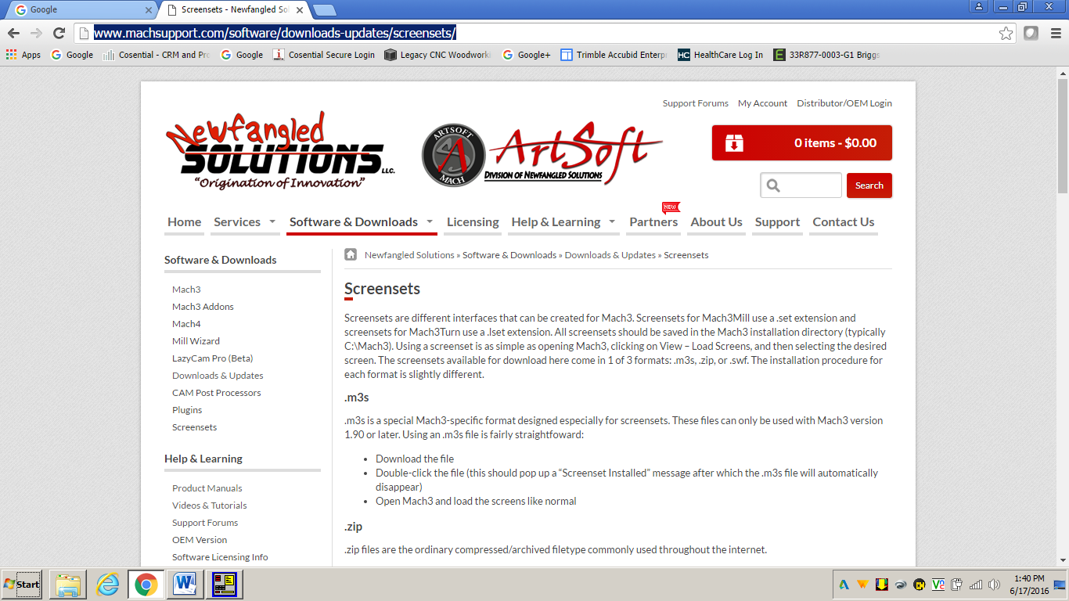
Scroll down to Screen Designers, Select Screen4, which will download the zip file to your computer.
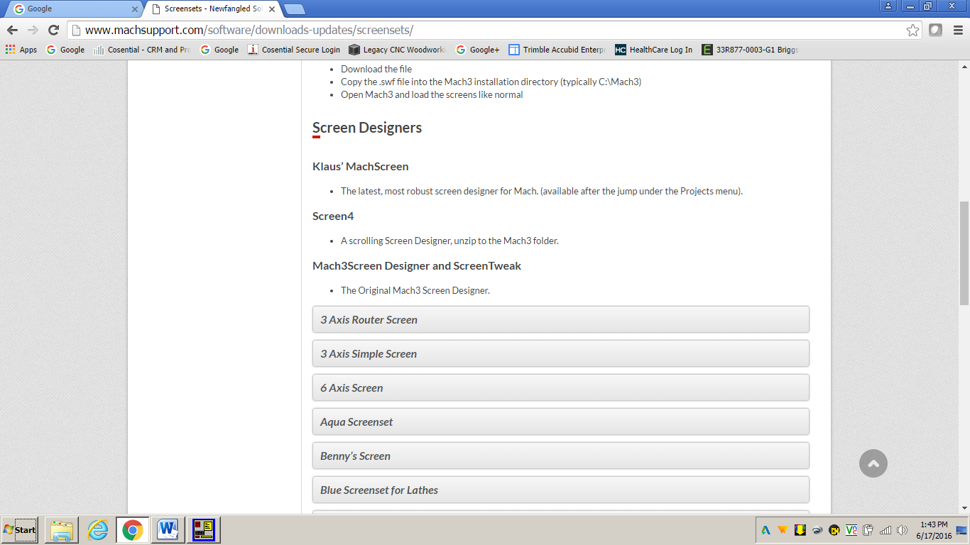
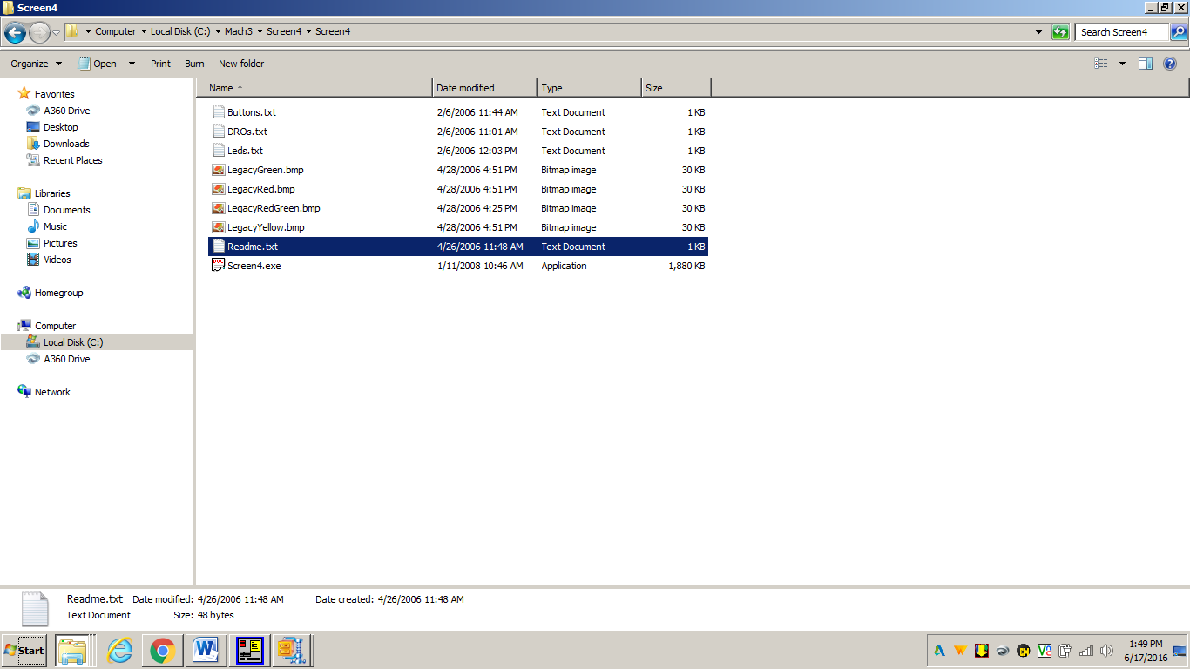
Save Screen4 in Mach3 Folder

Open Screen4
Open your Screenset File, i.e. Artisan H2O Spindle Rev E.set
Double Click on desired Button, in this case, the Cont Jog Button.
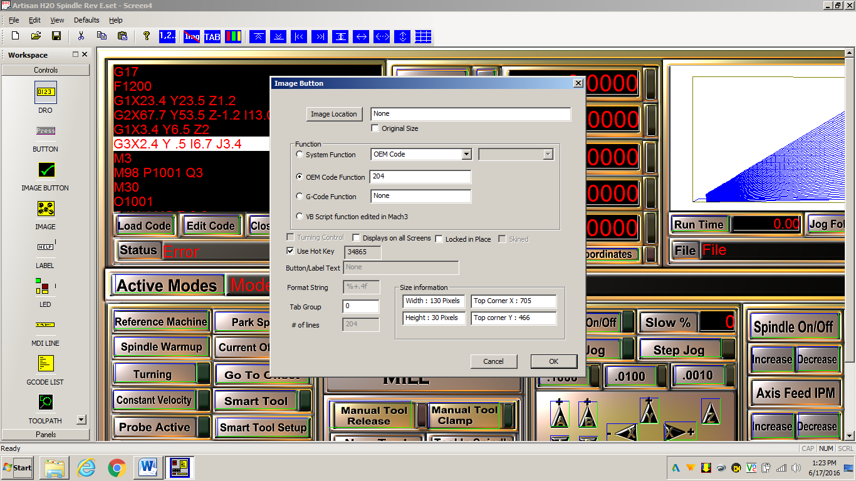
Click Hotkey checkbox to turn off.
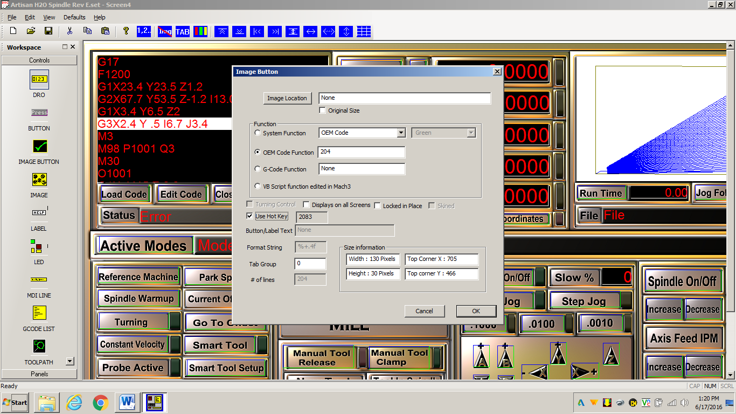
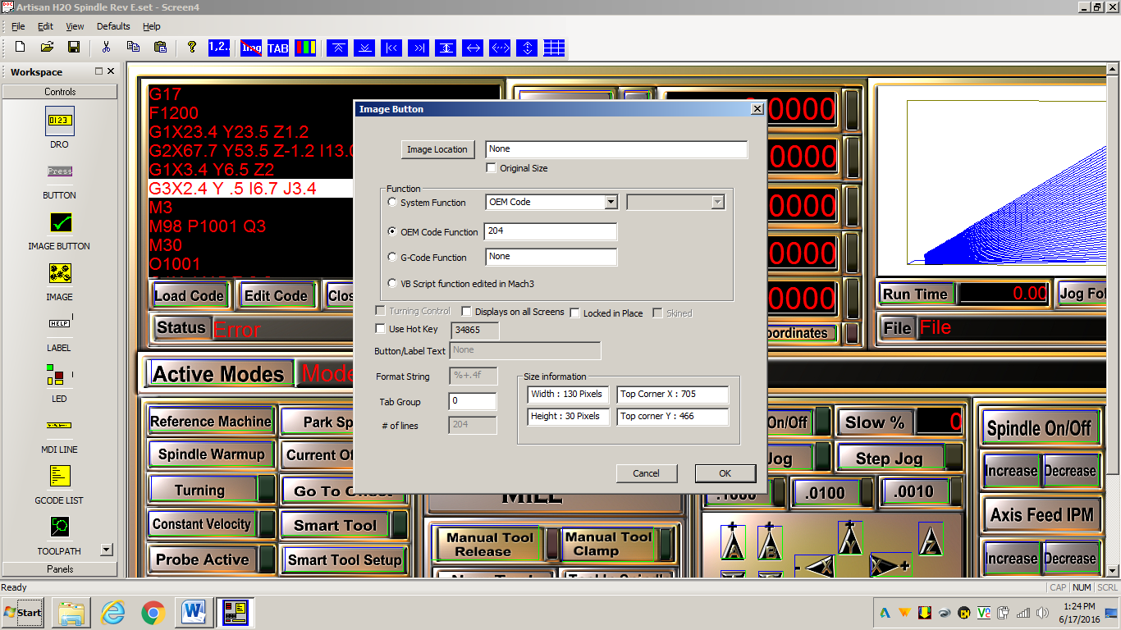
Click Hotkey checkbox to turn on.
When prompted to type the Hot Key Now,
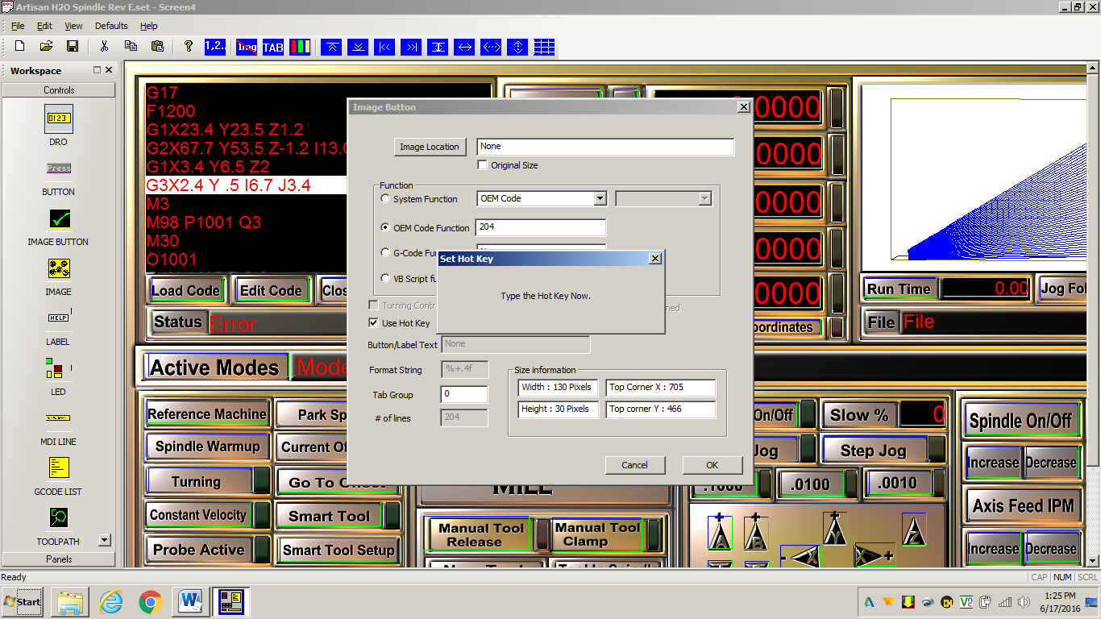
In this example, Alt-Cntrl-1 was type in,
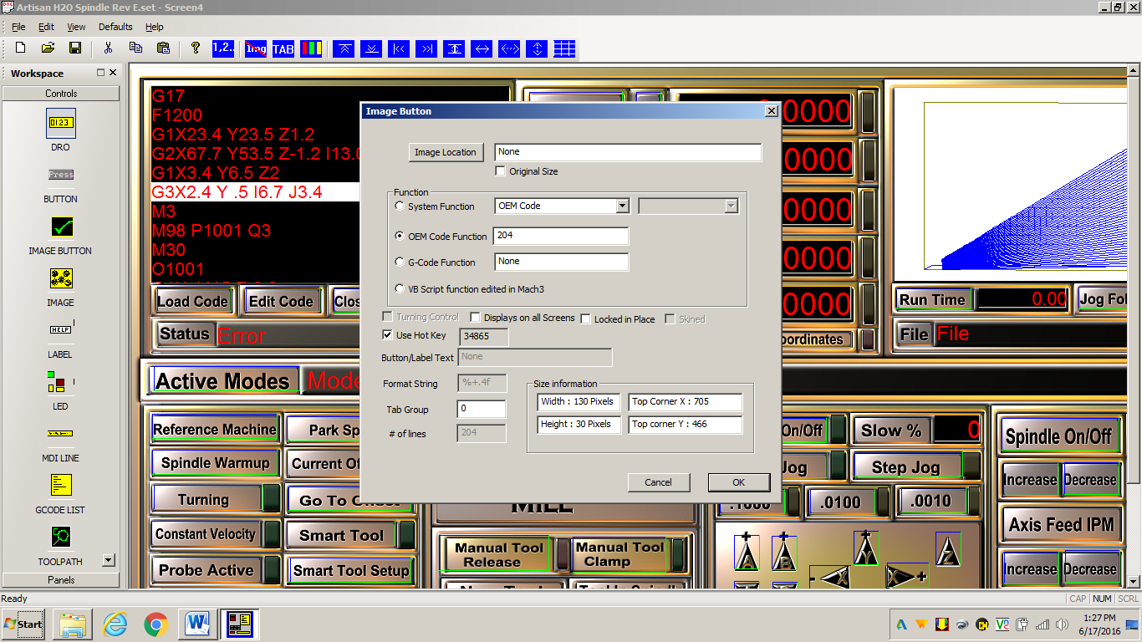
Then press OK in the dialog box. Your hot key is now assigned. Continue this process with the buttons you desire to assign hot keys to.
This is the process I used to assign the hot keys to the functions I desired my KRS Corporation, LLC remote keypad to perform.
I have also attached a spreadsheet with the information on hot keys that I thought may be valuable. I will be assigning hot keys to other buttons as I see may be of value.
If you are interested, I could go through the same process to show how to setup the remote keypad.
Here is the contact information for the keypad. Kevin Stoops has been very good to work with and I highly recommend his product.

Kevin Stoops
kevin@bumpbar.com
Phone (913) 837-8237
KRS Corporation, LLC
107 S. Broadway
Louisburg, KS 66053

